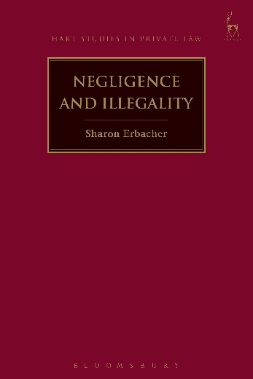
Negligence and Illegality
Sharon Erbacher

This book examines claims in negligence arising from illegal conduct of the claimant. An array of public policy and other grounds have been advanced for resolving these claims, resulting in an area that is characterised by confusing and contradictory case law. The book analyses the various explanations put forward as the basis for illegality doctrine within a framework of corrective justice theory.

Illegality law poses particular challenges for the corrective justice explanation of negligence law, as many illegality tests are based on public policy considerations external to the relationship of the parties.

The book argues that the only circumstance where illegality doctrine should be applied to deny a claim is where this is necessary to preserve the coherence of the legal system. It develops the work of Ernest Weinribian corrective justice theorists to explain how the principle of legal coherence fits within the framework of corrective justice theory, and why legal coherence is the only valid conceptual basis for a doctrine of illegality. It also contains a detailed study on the scope of the coherence rationale and the principles that will determine its application.

Sharon Erbacher is a Senior Lecturer at the Law School at Deakin University, Australia.

January 2017 | 9781509906666 | 272pp | Hardback | RSP: £60
Discount Price: £48

Click here to order online and use the discount code CV7 at the checkout to get your 20% off

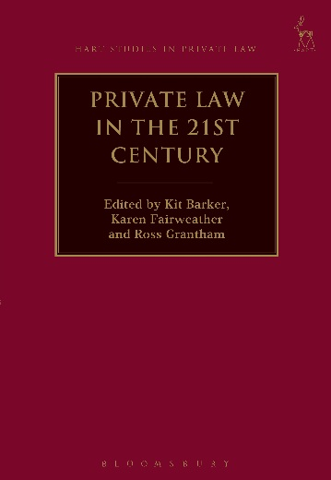
Private Law in the 21st Century
Edited by Kit Barker, Karen Fairweather and Ross Grantham

This book brings together a wide range of contributors from across the common law world to identify and debate the principal moral and systemic challenges facing private law in the remaining part of the twenty-first century. The various contributions identify serious problems relating to complexity and overload, threats to research and education, the law’s unintelligibility, the unsatisfactory nature of the law reform process and a general lack of public engagement. They consider the respective future roles of statutes, codes, and judge-made law (in the form of both common law and equitable rules). They consider how best to organise the private law system internally, and how to co-ordinate it externally with other public and economic systems (human rights, regulation, insurance markets and social security frameworks). They address the challenges for private law presented by new forms of technology, and by modern demands for the protection of new and intangible forms of moral interest, such as interests in privacy, ‘vindication’ and ‘personal choice’. They also engage with the critical contemporary debates about access to, and the privatisation of, civil justice. The work is designed as a source of inspiration and reference for private lawyers, as well as legislators, policy-makers and students.

Kit Barker is Professor of Law, Karen Fairweather is Associate Lecturer in Law and Ross Grantham is Professor of Law, all at the TC Beirne School of Law, The University of Queensland.

January 2017 | 9781509908585 | 624pp | Hardback | RSP: £110
Discount Price: £88

Click here to order online and use the discount code CV7 at the checkout to get your 20% off

